**Mohidin, Abdul Latiff bin Haji (1938– )**

Born on August 20, 1941 in Seremban, Negeri Sembilan, Abdul Latif bin Haji Mohidin, better known as Latiff Mohidin, is a Malaysian painter and poet, whose works are emotional, expressive and gestural. As a child prodigy, Latiff Mohidin was called 'Boy Wonder' from the age of 11 for his talent in art and was sent on a (DAAD) German Academy Student Exchange Scholarship to Germany where he began his studies at the Hochschule der Künste in Berlin in 1960. In 1969, he took up printmaking at Atelier La Courrière, Paris, and Pratt Graphic Centre, New York. His works are identifiable by his use of brushstrokes, swathes of colour, texture and layers of oil paint with lines that are dynamic, possessing an energy of immediacy. His works combine visual elements as well as the verbal and gestural and, in this way, successfully present layers of perspective and meaning. Latiff Mohidin express his personal anguish on a blank canvas paying little attention to form, style, or subject matter. In can be argued that his paintings, created in series, are an autobiographical acts of self-creation, the expressions of his personality as well as journeys into nature.

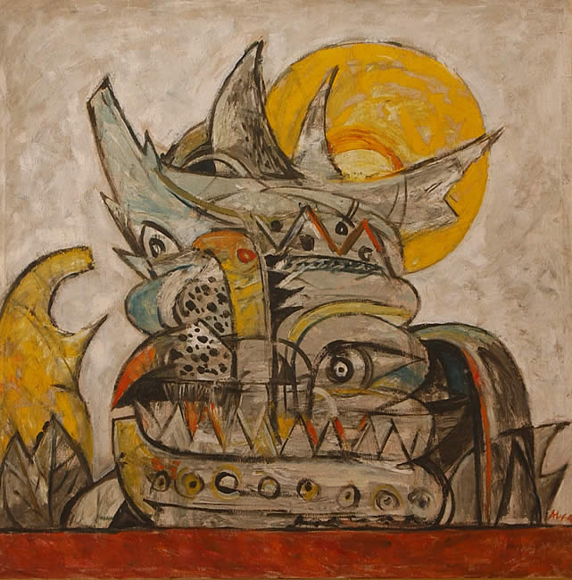

*Pago-pago (1964), 98 x 98 cm, oil on canvas.*

(Image taken from G*aris : Latiff Mohidin Dari Titik Ke Titik* Kuala Lumpur: Dewan Bahasa dan Pustaka, Kementerian Pendidikan Malaysia, 1988. Permissions to be obtained.)

Abdul Latif is recognized as one of the key artists in Malaysia, holding many exhibitions in Asia and in Europe including a major retrospective show at The National Visual Arts Gallery in 2012-2013. His training in West Berlin is reflected in some of his early work, which demonstrates affinities with the German Expressionists such as Kirchner and Max Beckmann. While he may have utilised abstraction in his *Pago-Pago* Series (1964-1969), Expressionism is his primary artistic strength, as demonstrated in his later series such as *Gelombang* (1988), *Rimba* (1997) and *Voyage* (2001). The 1970s witnessed a change in Latiif’s work as apparent in his *Mindscape* Series (1974 and 1982) and *Langkawi* (1976-1980) in which his works became more unperturbed and emotionally detached.

In addition to his artistic activity, Latiff Mohidin is also an accomplished poet. He wrote a poem entitled ‘Mekong River’ which later became the title of his first poem anthology. His poems are rich in imagery, metaphor, fresh and simple expression that has brought a new breath in the development of poetry in Malaysia. He has produced seven anthologies, such as *Sungai Mekong, Kembara Malam, Wayang Pak Dalang, Pesisir Waktu, Serpihan Dari Pedalaman, Rawa-Rawa* and *Sajak-Sajak Dinihari*. His poems have been translated into English, Chinese, German, Italian, Danish, and Tamil.

**References and further reading**

---- (2012) *60 Tahun Latiff Mohidin: Retrospective*. Kuala Lumpur: National Visual Art Gallery.

Mohidin, Abdul Latiff. (1988) *Garis : Latiff Mohidin Dari Titik Ke Titik* Kuala Lumpur: Dewan Bahasa dan Pustaka, Kementerian Pendidikan Malaysia.

Sabapathy, T.K., ed. (1994) *Pago-Pago to Gelombang: 40 Years of Latiff Mohidin*, Singapore: Singapore Art Museum.

Sabapathy, T.K. (1998) *Latiff Mohidin Rimba Series*. Kuala Lumpur: Petronas, 1998.

Sabapathy, T.K. (2009) *Latiff Mohidin : Journey to Wetlands and Beyond: Drawings and Works on Paper, 1962-2006* Singapore: Singapore Art Museum, 2009.